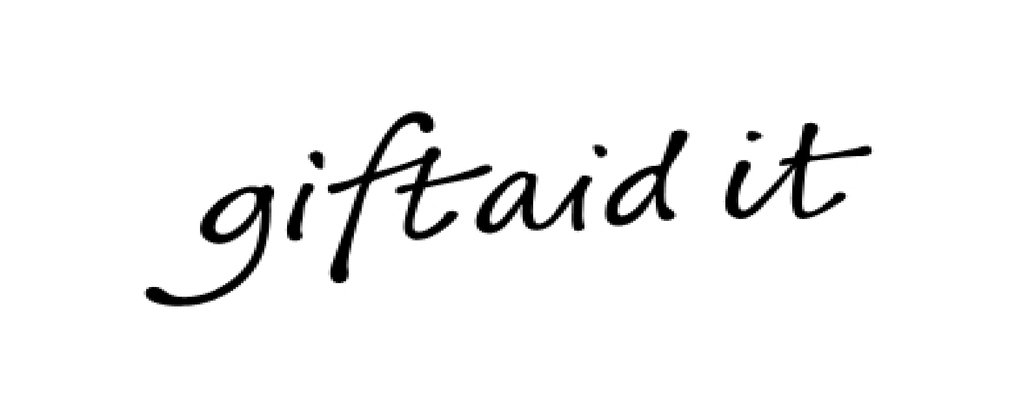
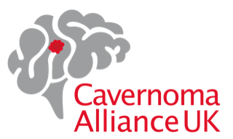

Gift Aid declaration for past, present & future donations

Name of charity: Cavernoma Alliance UK

Please treat as Gift Aid donations all qualifying gifts of money made:

Today ◻ in the past 4 years ◻ in the future ◻

Please tick all boxes you wish to apply.
I am a UK taxpayer and understand that if I pay less Income Tax and/or Capital Gains Tax than the amount of Gift Aid claimed on all my donations in that tax year it is my responsibility to pay any difference.

My details:
Title:
First name or initial(s):
Surname:
Full home address:
Post Code:

Date: ________________ Signature: ______________________________

Please notify the charity if you:
- want to cancel this declaration
- change your name or home address
- no longer pay sufficient tax on your income and/or capital gains

If you pay Income Tax at the higher or additional rate and want to receive the additional tax relief due to you, you must include all your Gift Aid donations on your Self-Assessment tax return or ask HM Revenue and Customs to adjust your tax code.
Please post your form to Cavernoma Alliance UK, Po Box 366, Watlington, OX10 1GF or email to: admin@cavernoma.org.uk. Thank you!

